## Première partie : Afficher les données :

### Code réaliser :

from scipy.io import arff

import matplotlib.pyplot as plt

data=arff.loadarff(open('./artificial/2d-10c.arff','r'))

listX = []

listY=[]

for point in data[0]:

listX.append(point[0])

listY.append(point[1])

plt.plot(listX,listY, 'ro')

plt.show()

### Affichage :

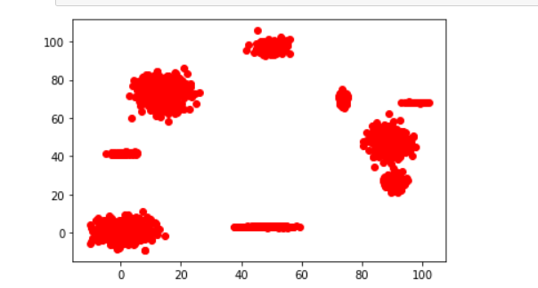

from sklearn.cluster import KMeans

from sklearn.datasets import make_blobs

import numpy as np

X = []

n_samples=1500

for point in data[0]:

X.append([point[0],point[1]])

X=np.array(X)

kmeans = KMeans(n_clusters=3, random_state=0).fit_predict(X)

plt.subplot(221)

plt.scatter(X[:, 0], X[:, 1], c=kmeans)

### Metrique

from sklearn import metrics

find = False

nb_cluster = 2

metric_best = 0

limit=20

iteration = 0

while(not find & (iteration < limit)):

kmeans = KMeans(n_clusters=nb_cluster, random_state=0).fit_predict(X)

find_metric = metrics.silhouette_score(X, kmeans, metric='euclidean')

if find_metric > metric_best:

metric_best=find_metric

nb_cluster+=1

else:

find=True

iteration+=1

print(nb_cluster)